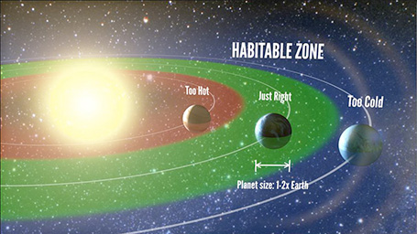 | 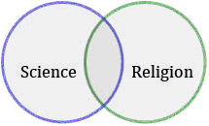 | 

Do you know why it is important that all major religions must start a serious dialogue with science? The answer is a growth of fundamentalism endangering our civilization.

Why not sign in and “Let us Reason Together” (Isaiah 1:18)

in an interdisciplinary course for all students including those on Erasmus Program at PALACKY UNIVERSITY:

DIALOGUE BETWEEN SCIENCE & RELIGION

(in STAG abbreviation KST/DNSR1)

Seminar starts at Sts Cyril-Methodius Faculty of Theology
on Wednesday September 27 at 17:20, Room U11 (4th floor)
(students with lesser English proficiency start at 16:30)

Evaluation: 4 credits for activity in class. Course concludes with colloquium.
Instructor: ThLic. Ing. Frantisek (Frank) Mikes, Ph.D. (fmikes@elabs.com)

- The Aim is to acquaint students with the importance of this course across all faculties.
- For Christians: To be acquainted with Evolutionary Christianity, taking dialogue with sciences seriously.
- For Other Religious Believers: To demonstrate the importance of leading a dialogue with science within any religious system.
- For Non-Religious Believers: A challenge for a common evolutionary journey – as a path of convergence of all humankind.
- Dialogue as an emerging process towards Global Spirituality.

“I encourage you to persevere in your search for truth.” (Pope Francis, May 12, 2017)
“Science without religion is lame and religion without science is blind.” (Albert Einstein)
“Science can purify religion from error and superstition and religion can purify science
from idolatry and false absolutes.” (Pope John Paul II.)

