!DO NOT FORGET TO ENROL THIS COURSE!
COMMUNITY DEVELOPMENT AND PARTICIPATION
MRS/KRP
Summer semester 2017
lecturer: Engela van der Klashorst (University of Johannesburg)
This course will provide students with a foundation in community development and participation. Theoretical and practical elements of community development will be explored by utilising case studies from the Czech Republic; Kenya; Gambia and South Africa. The community development process will provide students with a framework from which to apply principles of social change models and theories. Important aspects of community change, including building community sustainability and gender issues will be considered. Seven forms of community capital – social, human, physical, financial, environmental, political and cultural – will be incorporated in a practical exploration of community development. During this course, the student will be guided towards critical conceptual reflection and management of diversity in both local and globalised contexts.
The lecturer for the course will be Dr. Engela van der Klashorst. She is currently a lecturer at the University of Pretoria in South Africa. Engela has extensive experience in community development in the Sport for Development field. Her work with NGOs and civil organisations will ensure a thorough overview of community development for participants in the course.
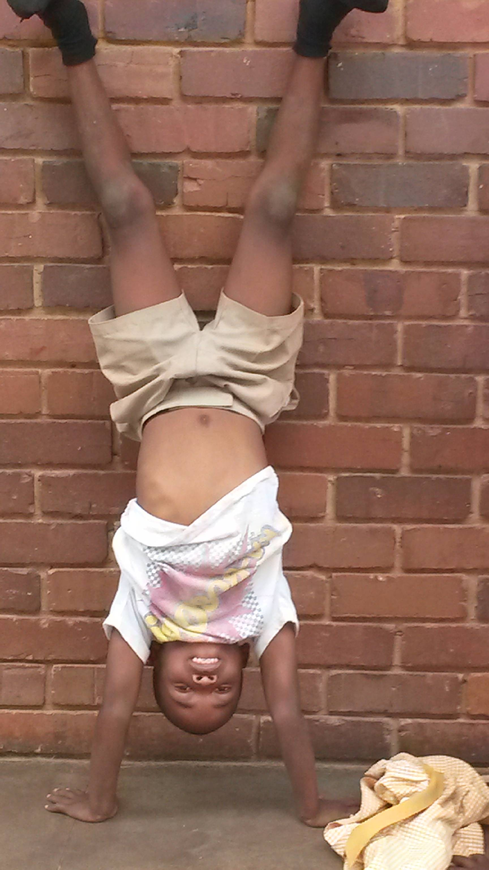 | 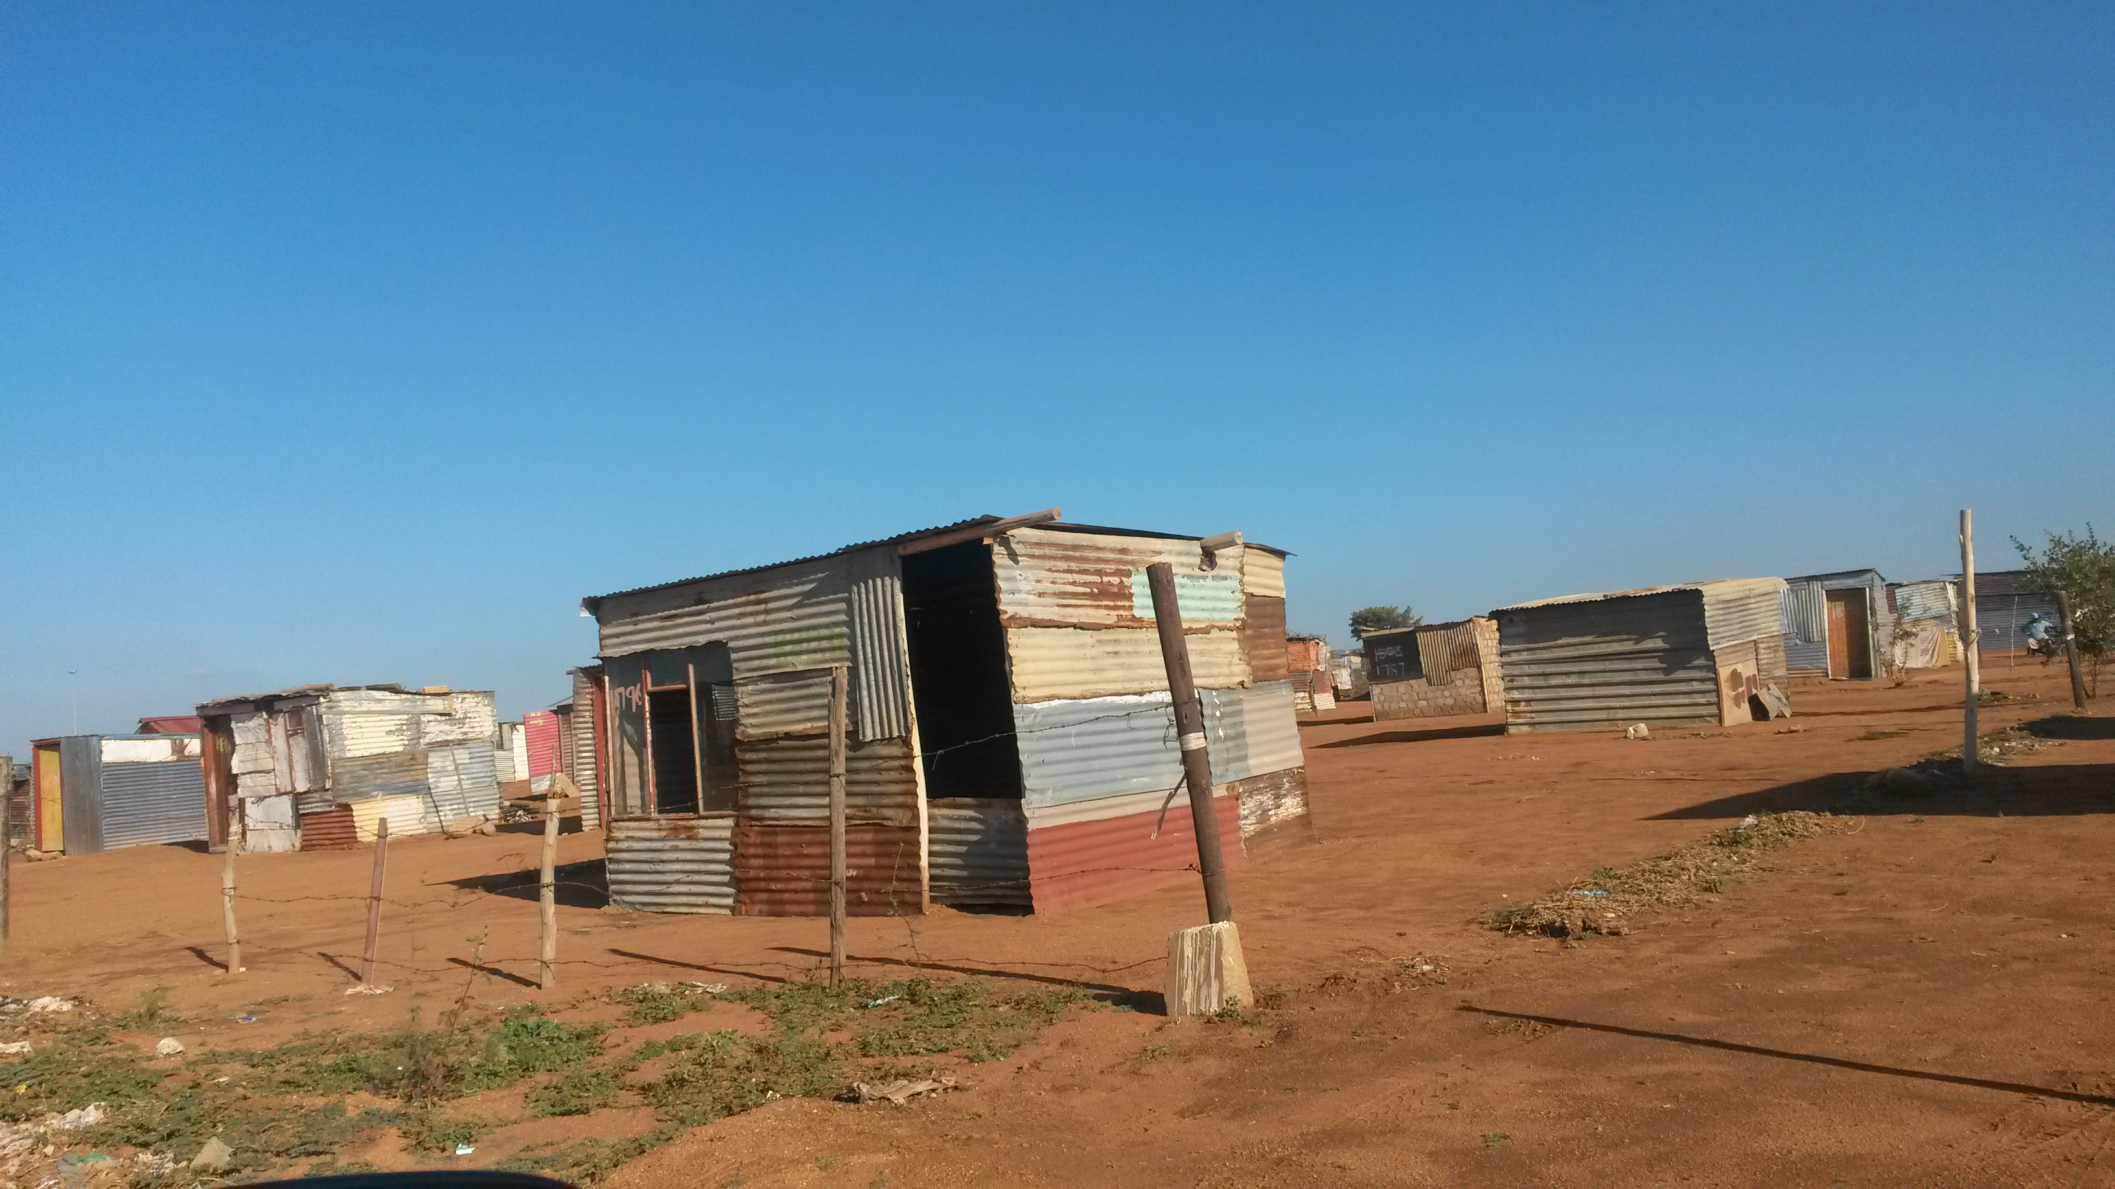 | 

Taught: each Wednesday 10:30 – 12:00 in room 1035
- the course will start in the 2nd week of the semester 22/2/2017

